**PHASE 1**

**Extract 1**

SOFTWOOD 

Trees are generally classified into either Hardwoods or Softwoods. Inexplicably, not all softwoods are soft and not all hardwoods are hard. For example, balsa, a hardwood, produces one of the softest woods in the world. Conversely, Douglas fir, a softwood, is harder and has better strength properties than many hardwoods. In simple terms, softwoods are needle-bearing trees and hardwoods are leaf-bearing.

Conifers

There are four families of Coniferales within the softwood group. The term conifer is used to describe a tree that's characterized by needle-like foliage- usually evergreen. Most softwood trees are characterised by the cone shape, a dominant stem, and lateral side branching. Most of the world's commercial softwoods grow in the northern hemisphere.

Needles and naked seeds

Botanically, softwoods are gymnosperms, which in layman's terms means the seeds are not enclosed in a flower. You'll often see the seeds borne on the scales of a cone, resembling small berries like those of a juniper, or in a cup such as on a yew. Although most conifers are evergreens, Mother Nature threw in a twist: Some conifers, like the larch, drop their needles in the fall.

Appearance

When converted into lumber, most softwoods are relatively light in color and range from pale yellow to reddish brown. The annual growth rings formed by layers of earlywood and latewood (see page 15) are typically very easy to distinguish. Most softwoods are fast-growing and are harvested primarily for manufacturing and construction-grade lumber.

HARDWOOD 

Hardwoods are generally heavier and denser than softwoods and so are much more sought-after by woodworkers for their projects. In addition, hardwoods offer a wide variety of color and grain options for the woodworker that softwoods just can't match (see below).

Deciduous

There are over 20 families of hardwoods in the United States alone. Most hardwood trees are deciduous, meaning their leaves fall off every autumn; this doesn't apply to all hardwoods, though. Those in tropical regions often keep their leaves year-round, and are evergreen. Most hardwood trees have a round or oval crown of leaves and a trunk that divides and subdivides (top photo). For the most part, broad-leaved deciduous hardwoods grow in the temperate northern hemisphere, and broad-leaved evergreens grow in the southern hemisphere and tropical regions.

Leaves and nuts

Botanically, hardwoods are angiosperms- the seeds are enclosed or protected in the ovary of the flower, typically a fruit or a nut. Protection can vary greatly, from the delicate skin of a pear to the tough shell of an acorn (inset).

Appearance

When converted into lumber, hardwoods offer a dizzying array of colors, figure, and grain. Colors range from the near white of holly to the jet black of ebony. Vibrant colors abound, such as the blood red of padauk, the bright orange of osage orange, and the deep violet of purpleheart. A combination of rays and vessels in hardwoods can produce wild effects in grain: ray fleck, tiger stripe, and fiddle back, to name a few (see pages 98-99). Growth rings of hardwoods can be difficult to distinguish; tropical hardwoods have virtually no growth rings since the growing season is year-round.

HOW A TREE GROWS

• Seeds are dispersed from a mature tree in a number of ways: Some seeds have broad-bladed wings to catch the wind, others have hooks to grab insects or are scented to attract birds. Most seeds never make it to a fertile spot where the conditions are right for sprouting. If the soil is warm, rich, and moist, a root tip and shoot tip will soon emerge. The root tip burrows into the ground and, via tiny hairs, absorbs moisture and elements essential for life. At the same time, the shoot tip grows upward toward light so that photosynthesis can occur. In its first year, the seedling will develop a special layer of regenerative cells called the vascular cambium, or simply the cambium. This important layer is only one cell thick and is what allows a tree to grow (see paae 11 for more on this). The cambium layer forms a complete sheath around the entire tree. As growth continues, new layers are added to the pith, which was formed by the original shoot. Side shoots, which ultimately become branches and finally knots, also begin in the pith. Sheathing the entire tree like this means that both height and girth are gained at the same time as annual increments of wood are laid down in a conelike form (see the drawina at riaht)

**Extract 2**

HOW A TREE GROWS

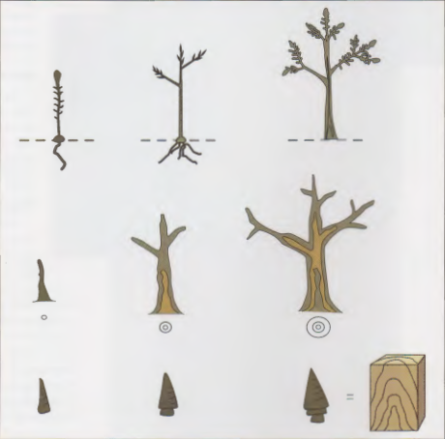

• Seeds are dispersed from a mature tree in a number of ways: Some seeds have broad-bladed wings to catch the wind, others have hooks to grab insects or are scented to attract birds. Most seeds never make it to a fertile spot where the conditions are right for sprouting. If the soil is warm, rich, and moist, a root tip and shoot tip will soon emerge. The root tip burrows into the ground and, via tiny hairs, absorbs moisture and elements essential for life. At the same time, the shoot tip grows upward toward light so that photosynthesis can occur. In its first year, the seedling will develop a special layer of regenerative cells called the vascular cambium, or simply the cambium. This important layer is only one cell thick and is what allows a tree to grow (see paae 11 for more on this). The cambium layer forms a complete sheath around the entire tree. As growth continues, new layers are added to the pith, which was formed by the original shoot. Side shoots, which ultimately become branches and finally knots, also begin in the pith. Sheathing the entire tree like this means that both height and girth are gained at the same time as annual increments of wood are laid down in a conelike form (see the drawina at riaht).

Bast or Inner Bark

Heartwood

A look at the layers of a maturing tree (top drawing) shows what goes on inside. The outermost layer is bark composed of an outer, corky, dead covering, and an inner, living bark or "bast:' The inner bark carries food from the leaves to the growing parts of the tree. Sapwood transports sap from the roots to the leaves; heartwood is formed by a gradual change in the sapwood and is inactive (see below). Rays are horizontally oriented tissues that connect various layers from pith to bark for storage and transfer of food.

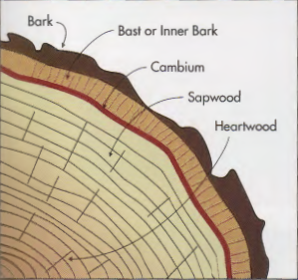

Cambium

Between the inner bark and the sapwood is the cambium, which actually forms the wood and bark cells. Cells divide frequently and each may become either a bark cell or a wood cell. Wood cells form on the inside of the cambium; bark cells form on the outside. New wood is laid down on top of old wood, and the diameter of the trunk increases. The existing bark is pushed outward by the new bark creating its familiar cracked and stretched appearance.

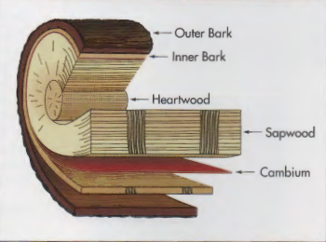

Heartwood and sapwood

As the end of the growing season nears, the tree's large crown of leaves often produces more food than it can use (middle photo). This excess food (called photosynthate) moves from the inner bark through the rays to the center of the tree. Here it accumulates and over time breaks down to form compounds known as extractives, which plug up the cells and eventually kill them. This area of extractive-impregnated dead cells is the heartwood. Frequently, the extractives darken the heartwood and give it its characteristic color (bottom photo).

A cross section cut from a tree (top photo) shows a distinct boundary between heartwood and sapwood. The cross section shown here is of yellow poplar; the heartwood is easily recognizable by the green center section in contrast to the lighter sapwood. Peeling the tree also helps to display the different layers and clearly define their proportions (middle drawing). Note: The only thing here not to scale is the cambium; remember, it's only a cell or two in thickness. Removing the dead, rough outer bark reveals the smooth, lighter inner bark where food in the form ofphotosynthate is transported from the leaves to the center of the tree. Rays in the inner bark align with the rays in the sapwood and heartwood to funnel the fluids inward.

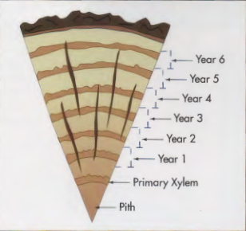

Growth rings

New wood cells that form early in the growing season are large and have thin walls. Later in the year, new cells are smaller and have thicker walls (see page 14 for more on cell structure). As the cells build on top of each other, layers form. Layers of early cells and late cells can be easily distinguished from each other by their width and color. Typically, the early cell layer is light and wide, and the layer oflate cells is thin and dark. In temperate regions, one layer of early cells and one layer of late cells define one growing season. This combination is referred to as an annual growth ring. The age of a tree can be quickly determined by counting the rings; the tree shown in the bottom drawing is seven years old. This tree-dating process is known in the science world as dendrochronology.

--

**Extract 3**

GRAIN

A woodworker can't talk about wood without the word grain popping up immediately. The problem is, grain means different things depending on how it's used. For example, "that wood has uneven grain;' and "oak has coarse grain;' and "use a block plane on end grain" all describe different characteristics of grain. Grain can describe planes and surfaces, such as radiaL tangential, and traverse (top drawing). It can describe growth-ring placement, such as edge grain, rift grain, and side grain, or growth-ring width (open grain and close grain), and even the contrast between earlywood and latewood (even grain and uneven grain). Grain can also illustrate the alignment of cells (acrossthe-grain, along-the-grain, with-the-grain), note the pore size (fine grain, coarse grain), express different types of figure (curly grain, roey grain, quilted grain), and define machining defects like chipped grain, fuzzy grain, and raised grain. Technically, grain is defined as the direction of the wood fibers in a tree. A radial surface, and therefore radial grain, is created when you cut along the radius of a round cross section. When a log is cut like this, it is said to be quartersawn, and the grain is usually straight and uniform. Tangential grain is created by cutting at a tangent to the growth rings. When a sawyer cuts logs like this, it is called plain- or flat-sawing. A traverse or cross section is what you get when you cut perpendicular to the wood fibers. Crosscutting a log this way produces end grain.

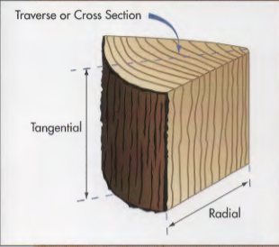

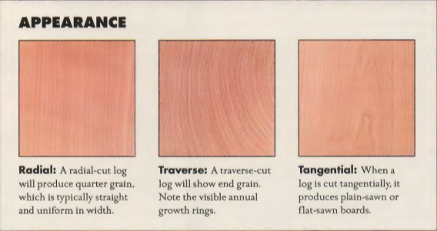

**PHASE 2 – (to be uploaded on April 15th)**

**Extract 4**

**Rose Wood , Teak Wood , Jungle Wood - Wood and Metal**

**Beach,Ash, Oak Wood – The Mallet**

**Extract 5**